# **PERFORMANCE ENGINEERING IN FORMULA 1 - ASSIGNMENT**

**Name: Sai Rishwanth Reddy Katham**

**Email ID: [rishikatham18@gmail.com](mailto:rishikatham18@gmail.com)**

**Mobile No: +1 7745267459**

# **Part 1: Calculations, Data Analysis preparation and Balance Evaluation**

**1.Derive expressions for:**

1. **Mechanical Balance**

**Ans:**

Total Lateral Load Transfer:

Wtotal = h.W.a / t

h = height of CoG

W = Total weight of vehicle

t = tr = tf = Track width assuming uniform track width across the car

a = Lateral Acceleration

Lateral Load Transfer Distribution:

Wf = (Kf / Kf + Kr).Wtotal

Wr = (Kr / Kf + Kr).Wtotal

Where, Kr and Kf = front and rear roll stiffness respectively.

Mechanical Balance = Wf / Wtotal

After Simplifying,

**Mechanical Balance = Kf / Kf + Kr.**

1. **Cd, Cl, Clf, Clr**

**Ans:** For Cd:

We know that Fd = (1/2)*ρ*A*Cd*v2

After rearrangement,

Cd = 2*Fd/ ρ*A* v2

Cd = 2*Fd/1.25*1*v2

**Cd = 1.6*Fd/v2**

For CL:

We know that FL = (1/2)*ρ*A*CL*v2

After rearrangement,

CL = 2*FL/ ρ*A* v2

CL = 2*FL/1.25*1*v 2

**CL = 1.6*FL/v2**

For CLf and CLr :

**CLf = 1.6*Flift,front/v2 , CLr = 1.6*Flift,rear/v2**

1. **Damper Travel, front and rear average**

**Ans:** Damper Travel front average = (SUS_Damp_Travel_FL+ SUS_Damp_Travel_FR)/2

Damper Travel rear average = (SUS_Damp_Travel_RL+ SUS_Damp_Travel_RR)/2

1. **Pushrod Loads, front and rear average**

**Ans:** Pushrod Load front average = (WHL_Load_FL+ WHL_Load_FR)/2

Pushrod Load rear average = (WHL_Load_RL+ WHL_Load_RR)/2

1. **Damper Travel, front and rear delta, Left-Right**

**Ans:** Damper Travel front delta = |SUS_Damp_Travel_FL - SUS_Damp_Travel_FR|

Damper Travel Rear delta = |SUS_Damp_Travel_RL - SUS_Damp_Travel_RR|

1. **Pushrod Loads front and rear delta, Left-Right**

**Ans:** Pushrod Load front delta = |WHL_Load_FL+ WHL_Load_FR|

Pushrod Load rear delta = |WHL_Load_RL+ WHL_Load_RR|

1. **Total Tyre Saturation, each corner**

**Ans:** Tyre Saturation FL = Tyre_Saturation_Long_FL

Tyre Saturation FR = Tyre_Saturation_Long_FR

Tyre Saturation RL = Tyre_Saturation_Long_RL

Tyre Saturation RR = Tyre_Saturation_Long_RR

Total Tyre Saturation = Tyre_Saturation_Long_FL + Tyre_Saturation_Long_FR + Tyre_Saturation_Long_RL + Tyre_Saturation_Long_RR

**2.Calculate Air Speed based on pitot measurements.**

**Ans:** Air speed = 1.6(AER_Pitot_Pressure + Static Pressure)

**2a. Create the Math Channel and provide an overlay of vCar and vAir**

**Ans:** 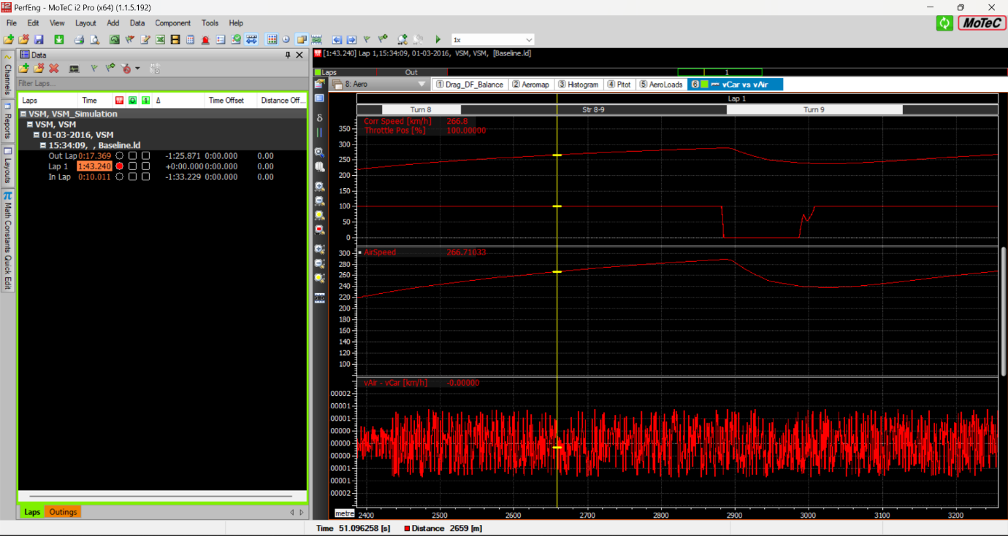

**2b. Was there any wind? Can you determine the wind speed and direction (head/tail) at the end of the straight before T9?**

**Ans:** Yes, there was a slight tailwind into copse T9. The wind speed is about 0.00001 kph. Don’t know if that is significant figure of speed to be considered also there is AER_Pitot_Pressure in data but I couldn’t find static pressure to calculate the wind speed so I just subtracted corrected speed from air speed.

**3.Calculate the Deadband and Stiffness of the front MC using the data.**

**Ans:** 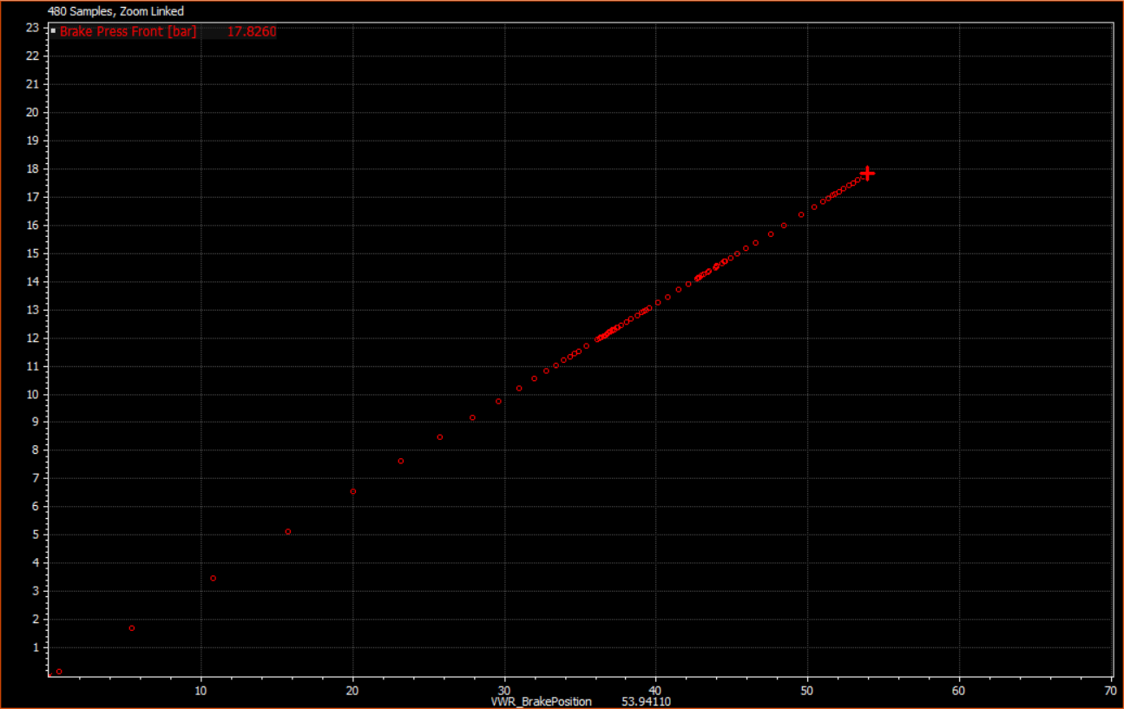

First reading of brake pressure above zero was achieved at 0.646% of brake position. So, 10% Brake Position = 1mm MC displacement then 0.646% Brake Position = 0.0646 mm MC displacement

**Deadband is 0.0646 mm**

As we know that Stiffness is equal to slope.

Slope = y2 - y1/x2 - x1 = 17.826 - 0.14803/53.94110 - 0.64644 =

0.332 bar per unit Brake Position = 3.32 bar per unit mm

**Stiffness is 3.32 bar/mm**

**4.Calculate the Aero Balance and Mechanical Balance on mid-corner HS T9 Copse - provide an overlay as reference. At this point, do you think the car is well balanced? Why?**

**Ans:**

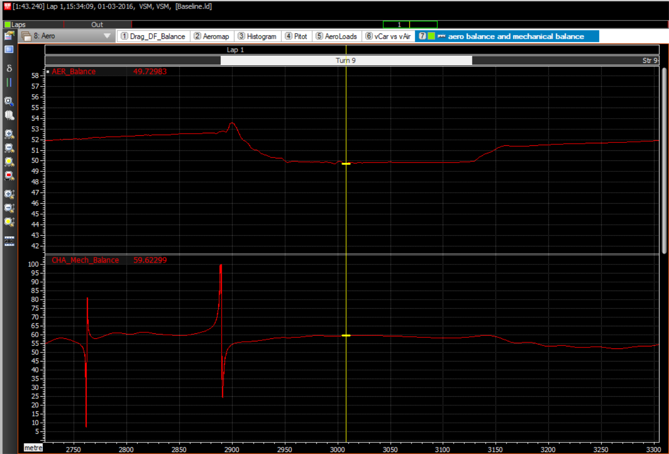

Aero Balance is 49.729 which indicates more rear downforce and Mechanical Balance is 59.623 which indicates weight distribution is more forwards in midcorner of T9. The ideal balance for high speed corners is more front downforce and mechanical balance should be more rearwards. The above values suggest that there is midcorner understeer in T9.

**5.Is there any front inside locking? Do we have room on the rear axle to change the Brake Balance? Justify your answer using the data as evidence.**

**Ans:**

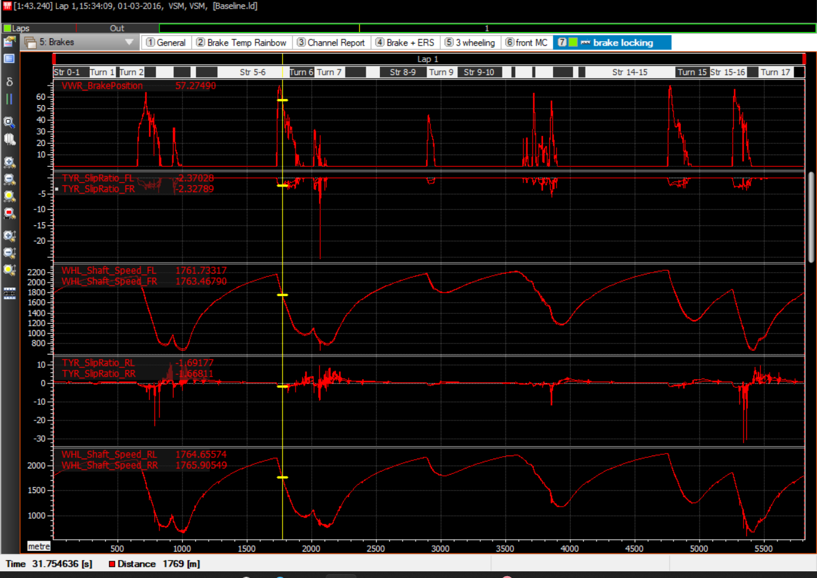

I think there is small lockup into T7(luffield) this is because tyre slip ratio of front right tyre suddently drops(-25.61) which indicates that tyre speed dropped much more than vehicle speed. Yes, There is room on the rear axle to shift brake balance rearwards because Tyre slip ratio for rear tyres is less than front tyres and Rear Wheel shaft speeds have more RPM than the Front wheel shaft speeds that means there is less decelaration on rear axle than on the front axle. So there is no problem in shifting the brake balance rearwards which improves overall braking efficiency and reduce load on front axle.

1. **What is the biggest limitation of this car? Could you propose any balance/setup modifications to improve its performance?**

**Ans:**

The biggest limitation of this car is the Understeer balance in both high speed and low speed corners which is indicated by the aero balance being more rearwards in high speed corners and mechanical balance being more forwards in low speed corners.

To counter this problem we can add more front wing flap or lower front ride height for better front downforce which improves the aero performance in high speed corners. For better mechanical balance in low speed corners we can make rear antiroll bar stiffer, rear suspension stiffer or increase rear ride height and shift the weight more rearwards reducing understeer in low speed corners.

1. **Is there any Heave Stiffness transition on the straights? Answer giving evidence.**

**Ans:**

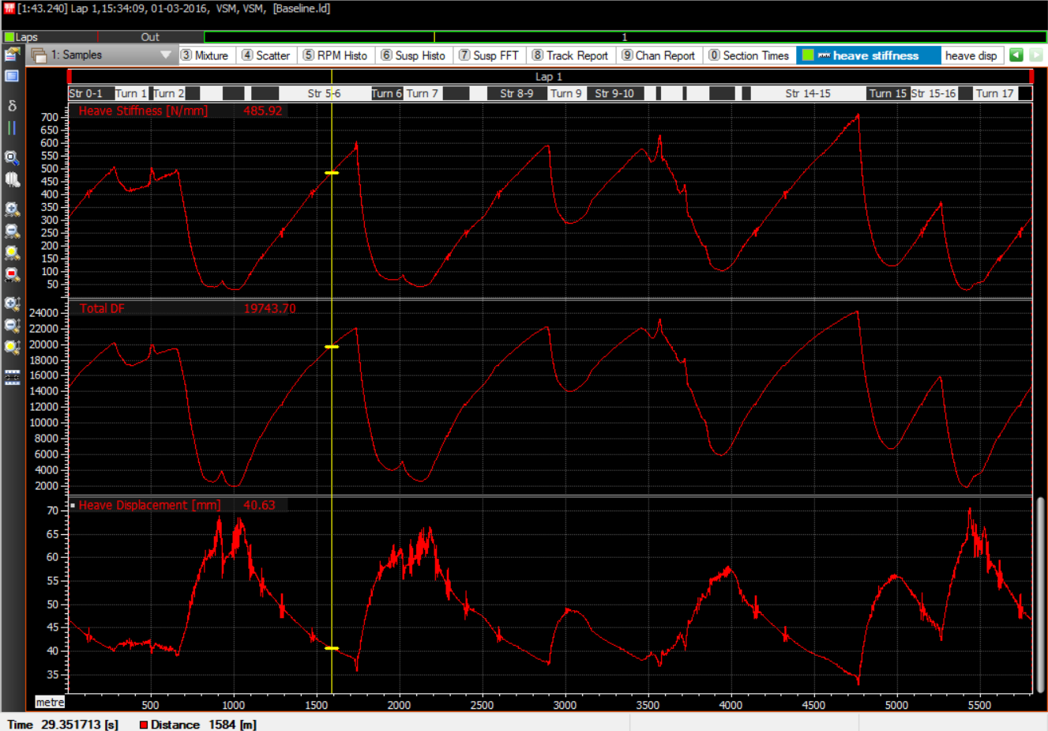

I calculated Heave Stiffness as ratio of Total Downforce and average change in ride height on all four corners throughout the lap.

Yes, There is heave stiffness on straights. Now let’s analyze heave stiffness on wellington straight before T5(Brooklands) as we can see in the graph on the exit of T4 the total downforce on the car is very low as the car went on the straight the total downforce has increased due to faster air flow around the car and ride height starts to drop because the downforce pushes car to the ground. As the aero load increases the heave stiffness increases helping the car to maintain ride height and avoiding bottoming out which increases plank wear and affects top speed.

# **Part 2: Setup Comparisons**

1. **Evaluate the main losses/gains and weaknesses of both setups. Would you fit it for the rest of the weekend?**

**Ans:**

Laptime is 0.86s slower than old setup mostly losing out on acceleration out of corners.

Less drag which increased the top speed by 3-4 km/h into T9 and T15. By using new rear wing we are able to carry more entry speed but losing on exit out of T6, T9, T15. It gives good stability in high speed direction change T10, T11, T12 (maggots and becketts) able to carry more speed through those corners and also downforce matching with old rear wing but again losing out on acceleration onto hangar straight before T15(stowe).

I wouldn’t fit the new rear wing for the rest of the weekend because even though we are able to achieve higher top speed with new rear wing compared to the old one but we are losing out on acceleration out of the corners and silverstone track has 2 long straights(wellington and hangar straight) with DRS activation and with that less acceleration out of the corners the car behind can easily overtake using DRS.

1. **What is the balance (aero and mechanical) at T9, through all corner phases: entry, mid, exit? Was the rebalance across wings done correctly?**

**Ans:**

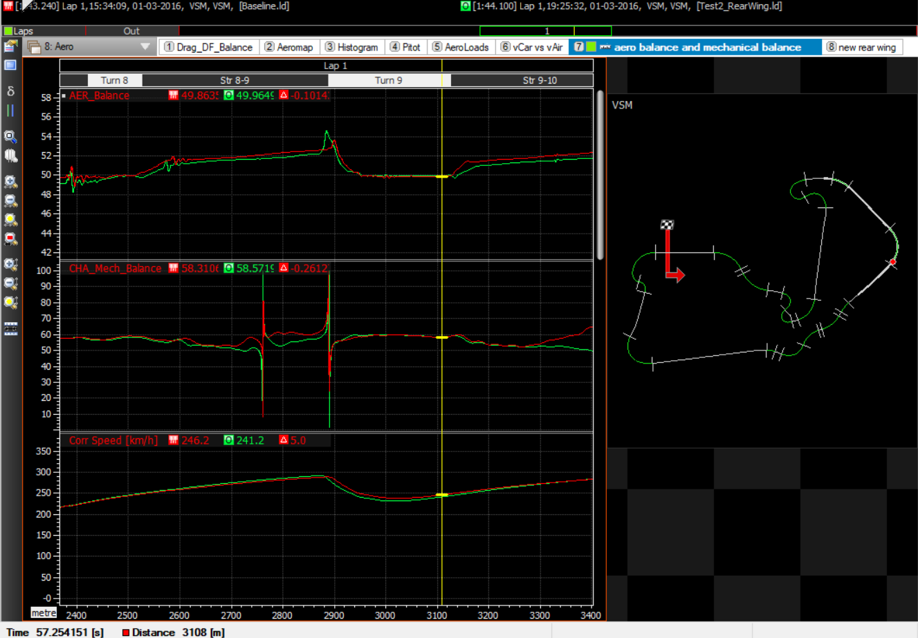

|  |  |  |
| --- | --- | --- |
| **Baseline** | **AB** | **MB** |
| Entry | 53.5 | 53.82 |
| Mid | 49.72 | 59.60 |
| Exit | 49.86 | 58.31 |

|  |  |  |
| --- | --- | --- |
| **Low drag RW** | **AB** | **MB** |
| Entry | 53.1 | 53.35 |
| Mid | 49.85 | 59.69 |
| Exit | 49.95 | 58.57 |

Rebalancing across on mid corner and exit of T9 seems alright for both aero balance and mechanical balance (<0.2% difference) meanwhile rebalancing on entry of T9 seems off (nearly 0.5% difference).

1. **What is the balance (aero and mechanical) at T15, through all corner phases: entry, mid, exit? How much time-loss does the new rear wing yield through this corner?**

**Ans:**

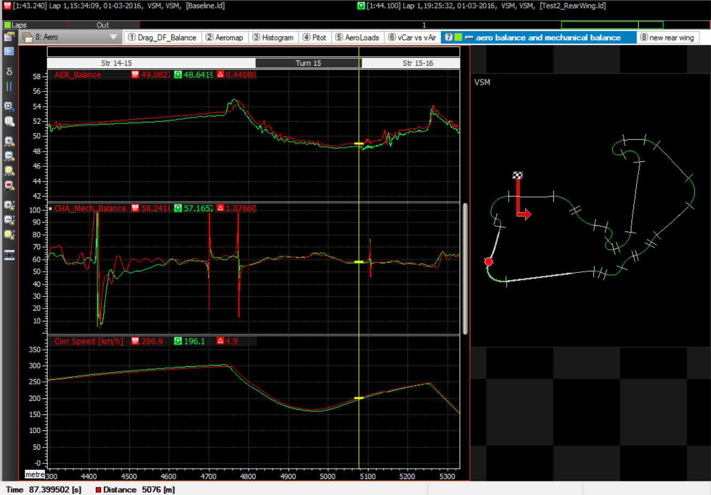

|  |  |  |
| --- | --- | --- |
| **Baseline** | **AB** | **MB** |
| Entry | 51.77 | 57.14 |
| Mid | 49.44 | 61.46 |
| Exit | 49.08 | 58.24 |

|  |  |  |
| --- | --- | --- |
| **Low drag RW** | **AB** | **MB** |
| Entry | 50.93 | 57.91 |
| Mid | 49.05 | 61.99 |
| Exit | 48.64 | 57.16 |

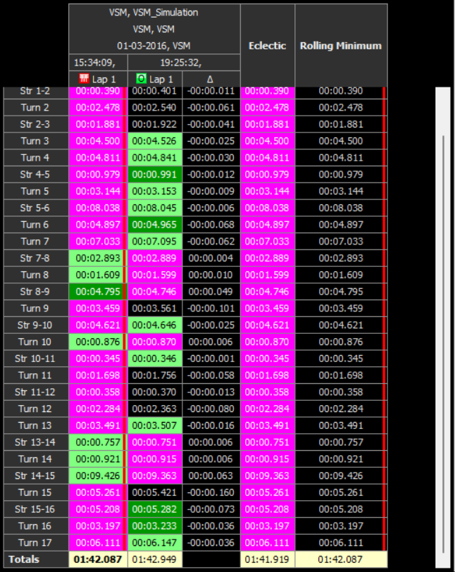

As we can see from the above time report there is 0.160sec time loss through T15

1. **How does the top speed differ across setups? What is the Cd points difference at EoS?**

**Ans:** The top speed calculated before T15 with baseline rear wing is 298.6 km/h and with new rear wing it is 303.1 km/h. There is a 4.5 km/h top speed difference between setups.

As we know that,

Cd = 2Fd / p.V2.A

Where Fd = Drag Force

p = air density(1.25 kg/m3)

V = car speed

A = Frontal area (assumed as 1.6m2 because it is minimum value according to regulations)

Cd(baseline) = 2x3754 / 1.25x(298.6 x (5/18))x1.6 = 0.545

Cd(new rear wing) = 2x3504.7/ 1.25x(303.1 x (5/18))x1.6 = 0.494

Therefore, The Cd points difference at the EoS is 0.051.

1. **What is the overall straight-line lap time gain across setups? i.e. the difference in total time spent on all of the straights combined**

**Ans:**

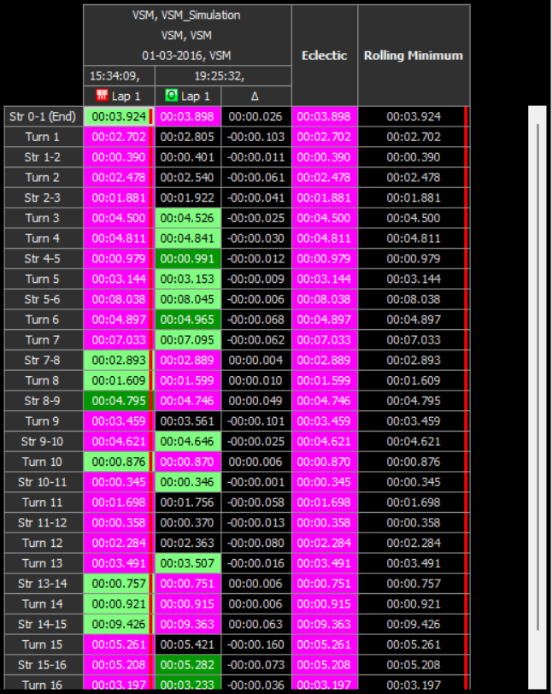

The overall lap time gain by using new rear wing 0.03sec on straights.

1. **If we focus on T9 HS mid-corner, can you say if there is any Aero Load difference across setups?**

**Ans:** 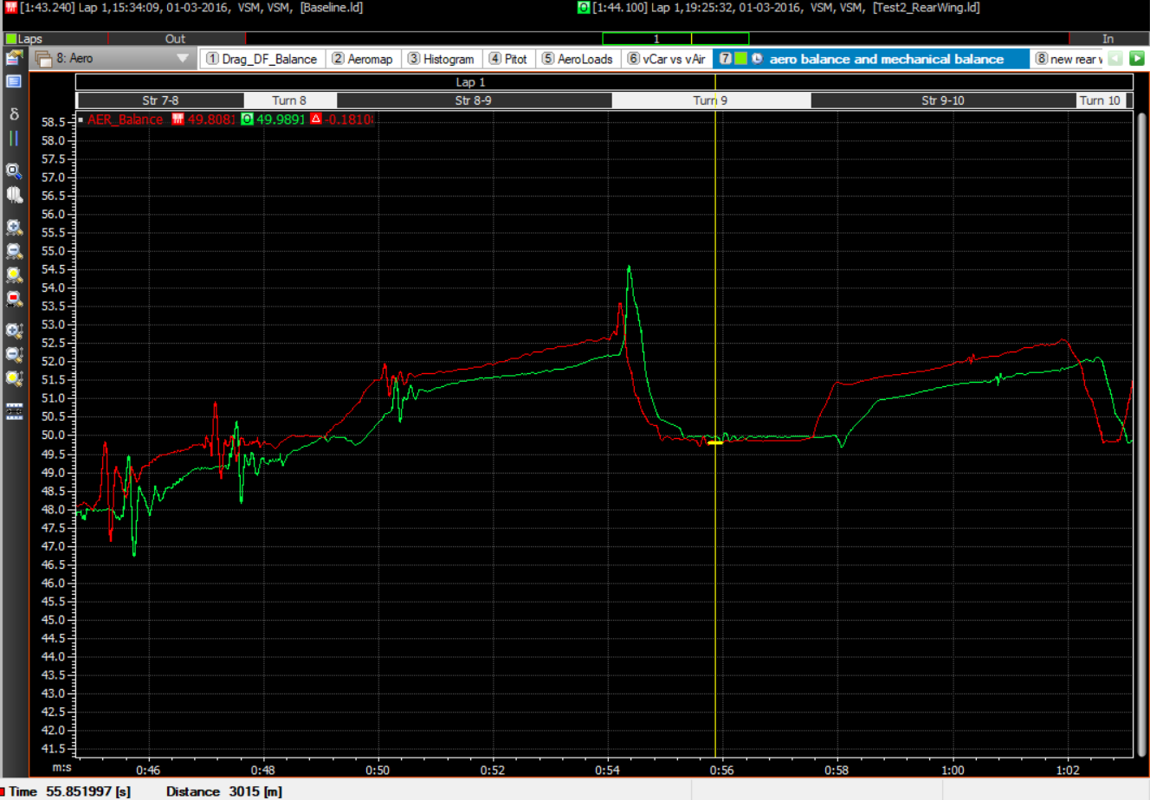

There is minor 0.1 difference between aero loads in midcorner of T9 copse across setups.

1. **Is there any sign of instability with this new Rear Wing? Justify your answer using the data as evidence.**

**Ans:**

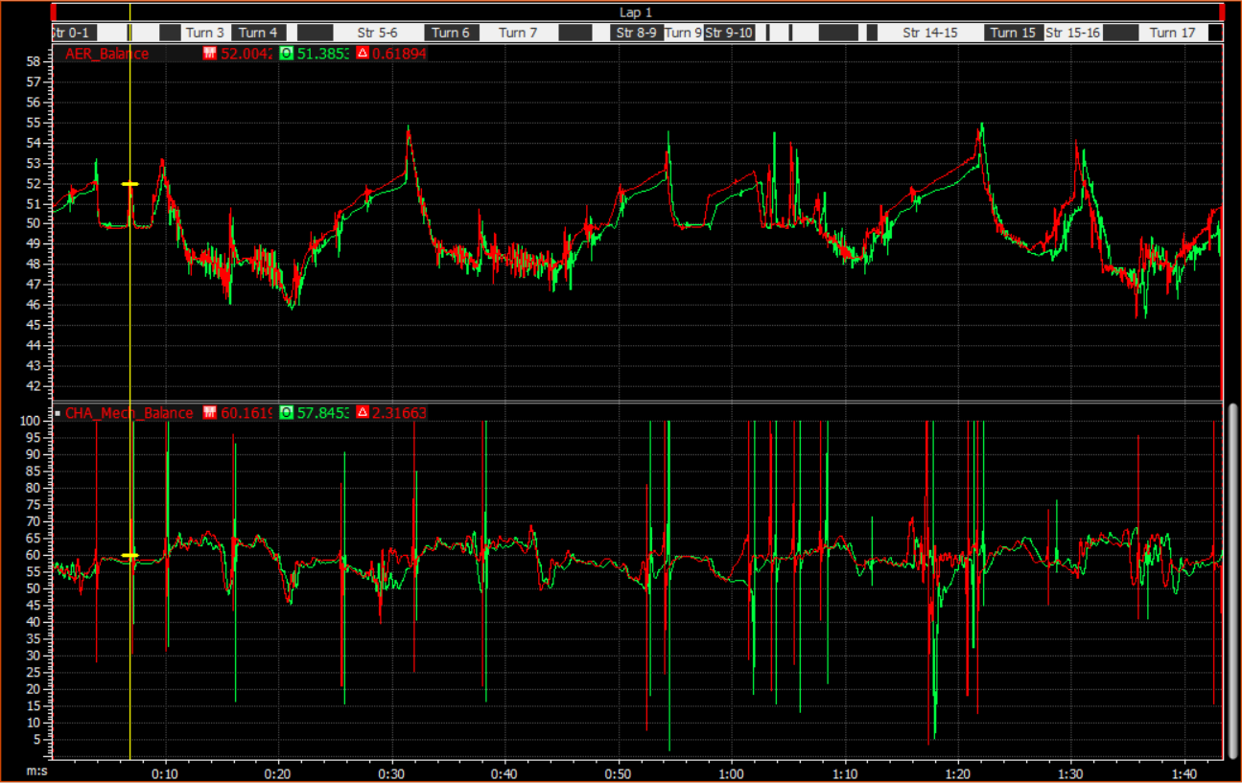

The aero balance and mechanical balance of baseline and new rear wing setup is almost same.

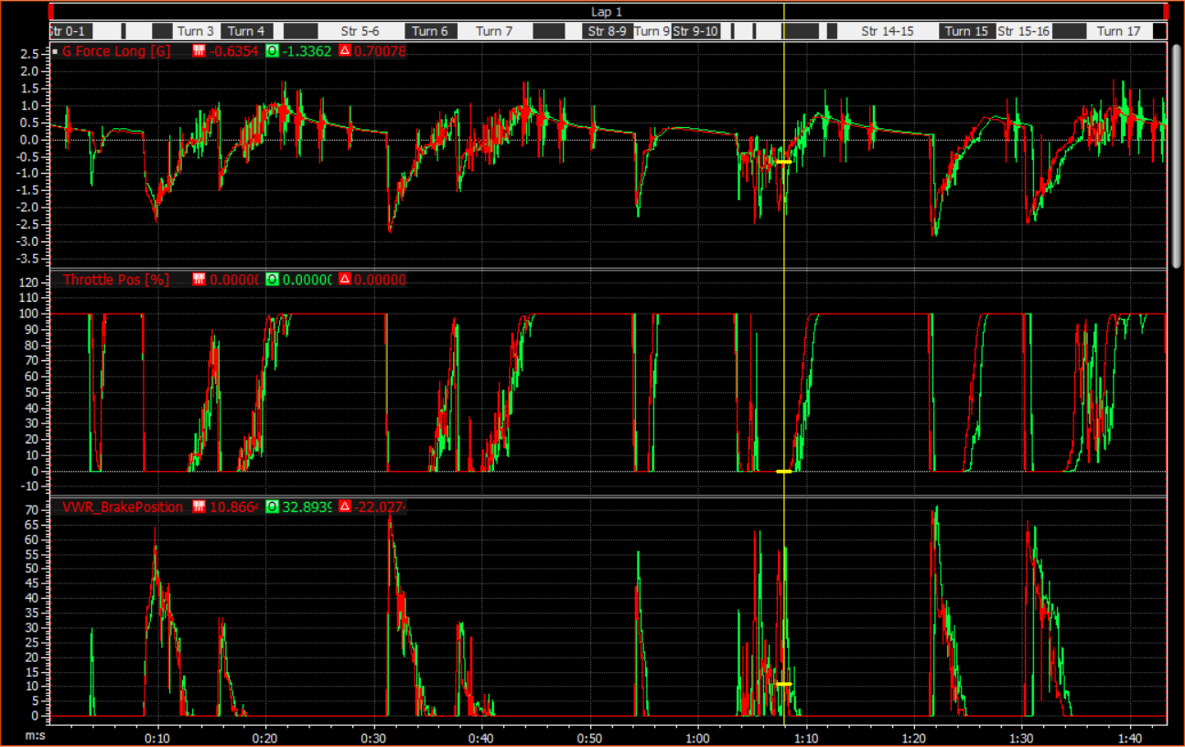

The driver is braking into T1 which is a high speed corner this means that the driver is not confident to take that corner flatout evident from brake trace little spike before T1.

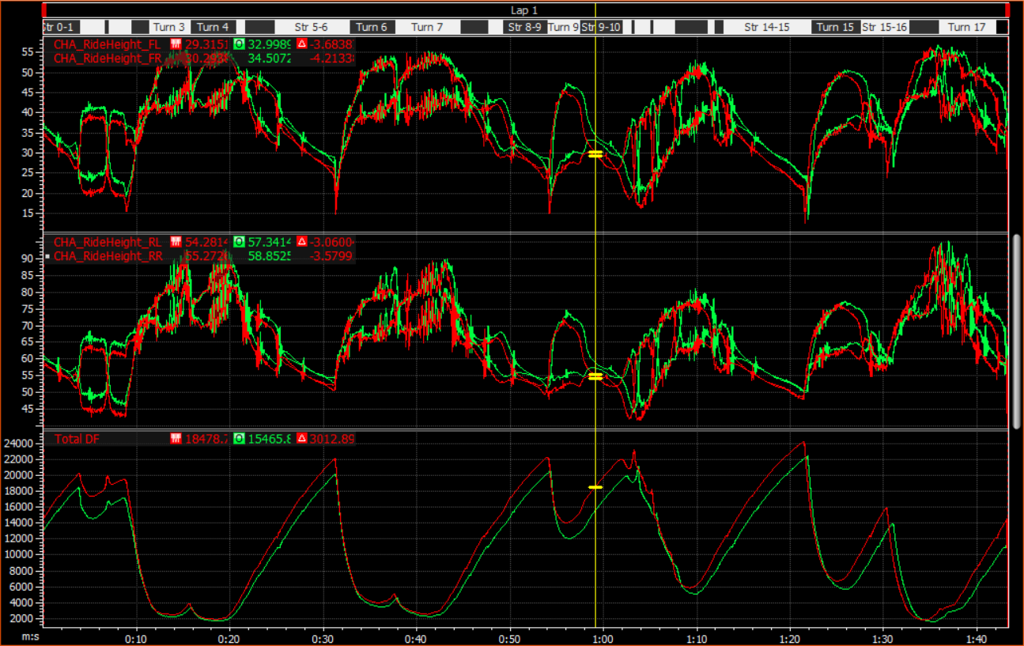

The Ride height vs Total Downforce overlay seems fine no sudden spikes or drops when compared with baseline setup.

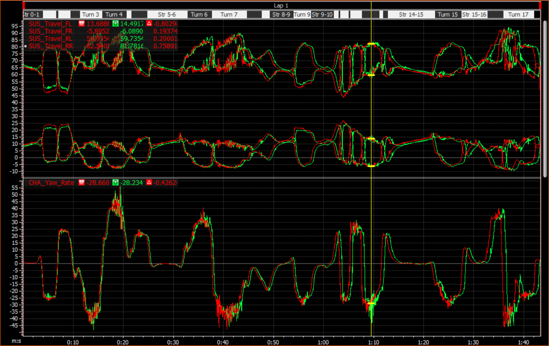

Similarly there is no evidence of instability in the suspension travel overlay but there is some instability in T13 as there is a sudden drop in yaw rate.

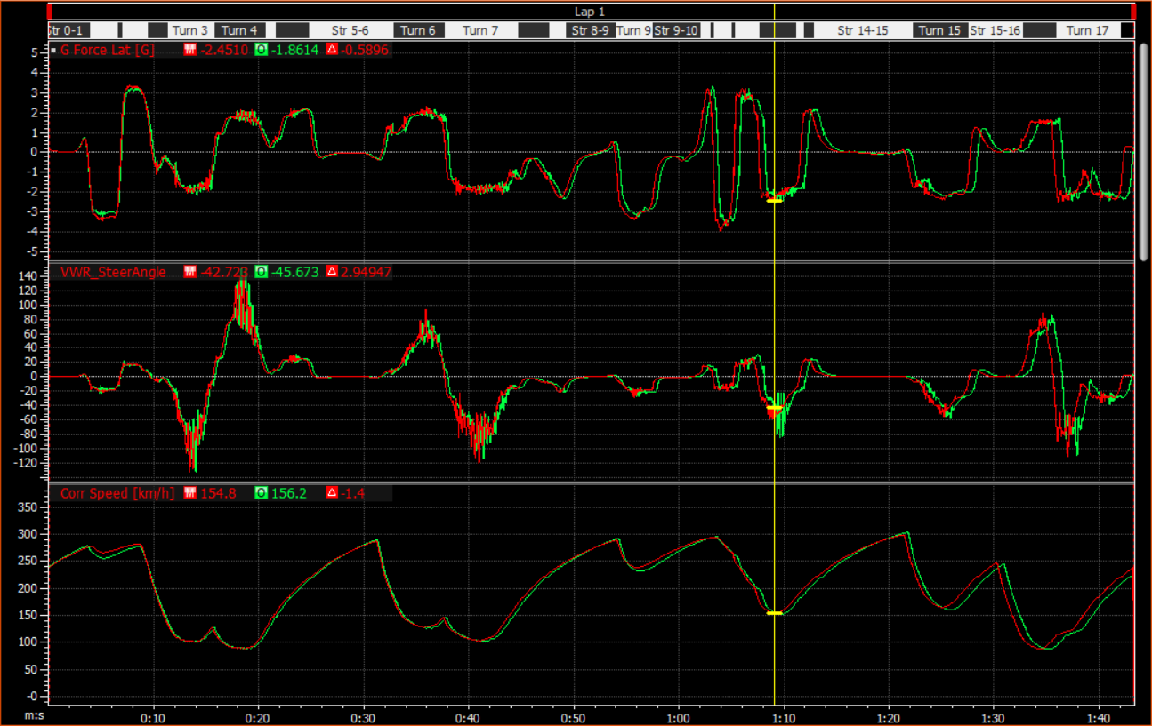

We can also see that there is a oversteer movement in T13 from Steer angle plot but we don’t see any instability with the balance. This might have happened because driver carried same speed into the corner as he/she did with baseline setup and the new rear wing couldn’t handle that load or it could be the cross wind which caused the car to unsettle.

**Front Third Test**

1. **Is the unit working as expected? Produce an overlay of the Heave Characteristics - indicate on the plot where you think the bump-stop is now being engaged, compared to the baseline.**

**Ans:**

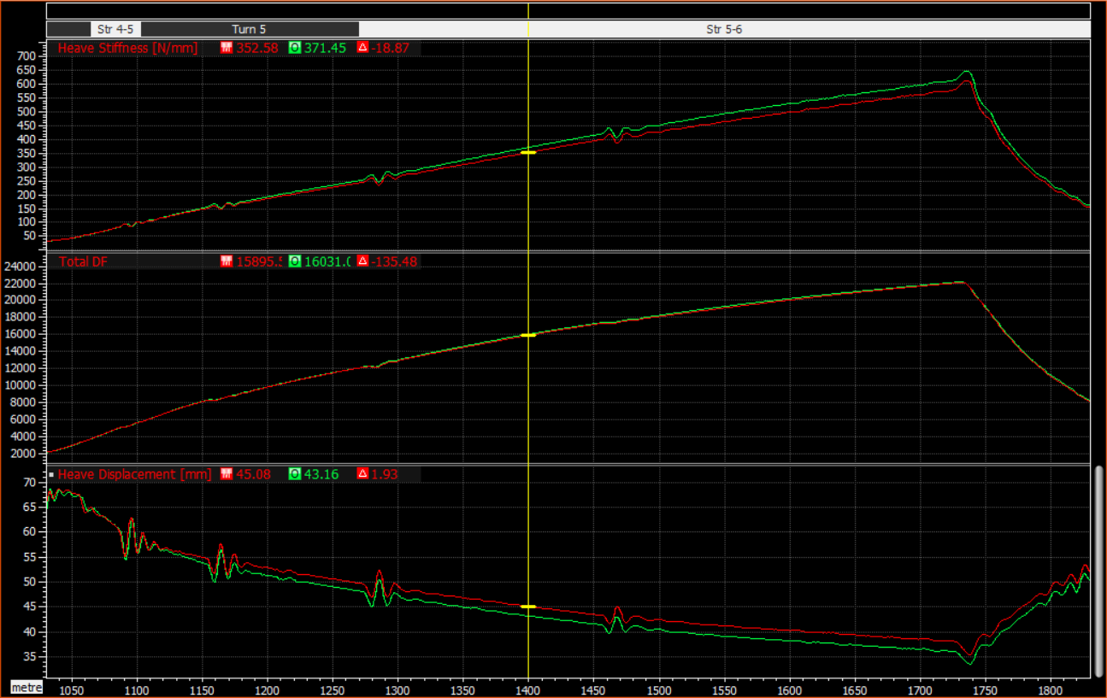

From the overlay it is clearly evident that heave displacement has increased compared to baseline setup as expected. The bump stop now has engaged at a heave displacement of 43.16mm and for the baseline setup bumpstop has engaged at 45.08mm.

1. **What is the straight-line transition speed of engagement for the bump-stop?**

**Ans:**

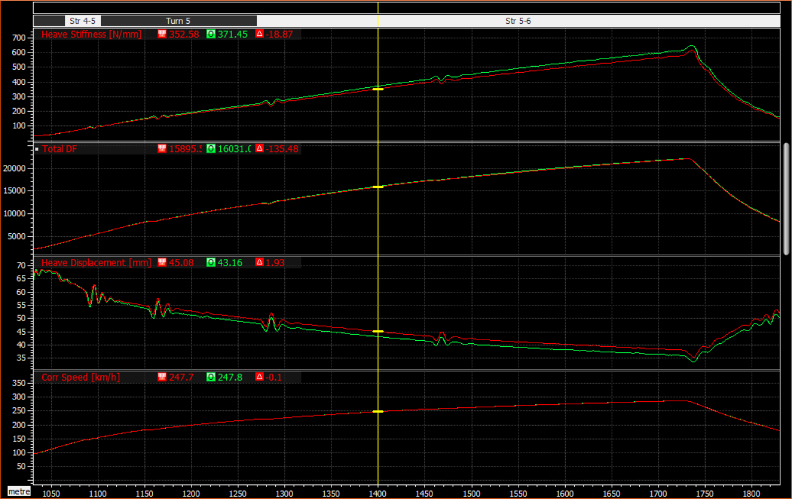

The Straight line transition speed of engagement for the bumpstop is 247.8 km/h.

1. **If the target was to rebalance the AB at Copse (T9), has this been done correctly?**

**Ans:**

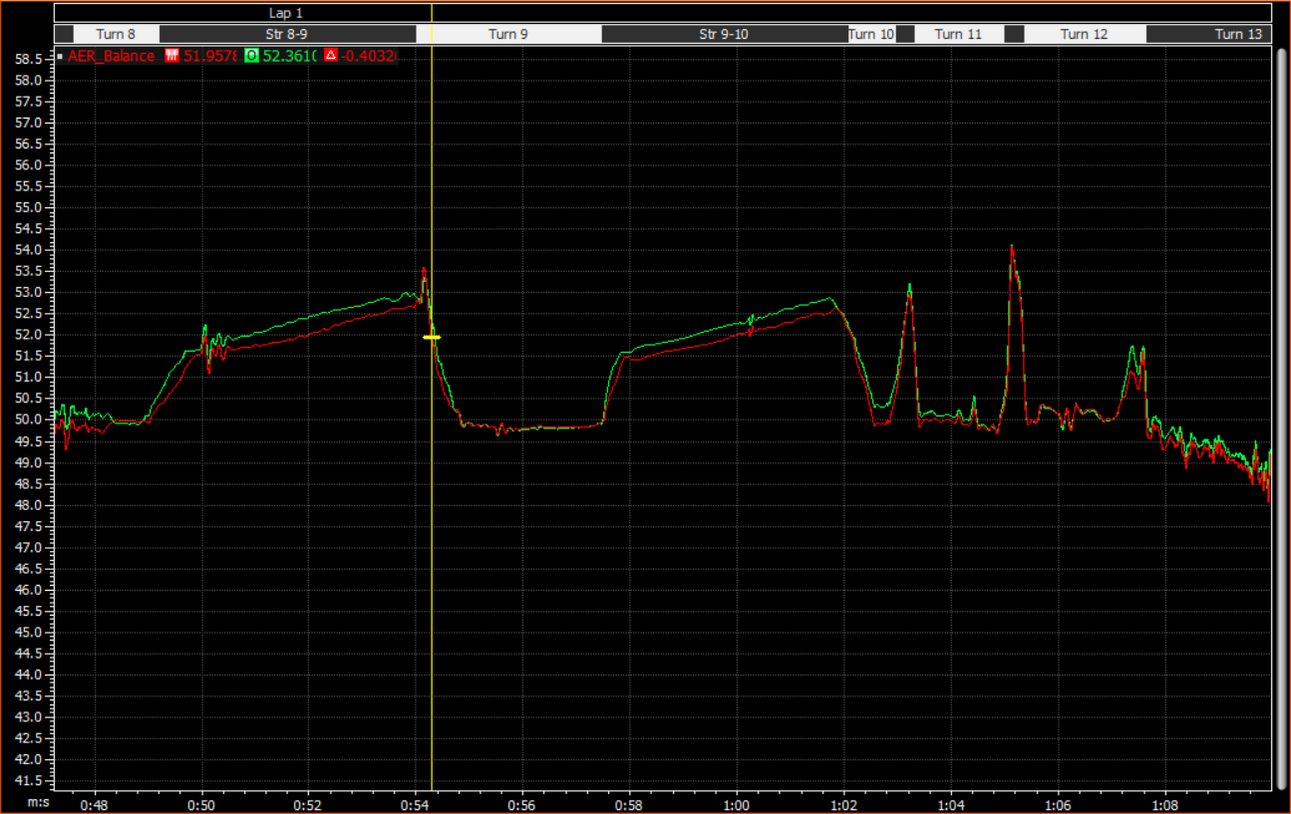

Yes, They did it correctly as we can see from the overlay the aero balance is slightly forwards on entry which gives more front downforce reducing understeer.

1. **Is there any point in which the car is bottoming-out with the new setup? At which place do we get closest to the track surface?**

**Ans:**

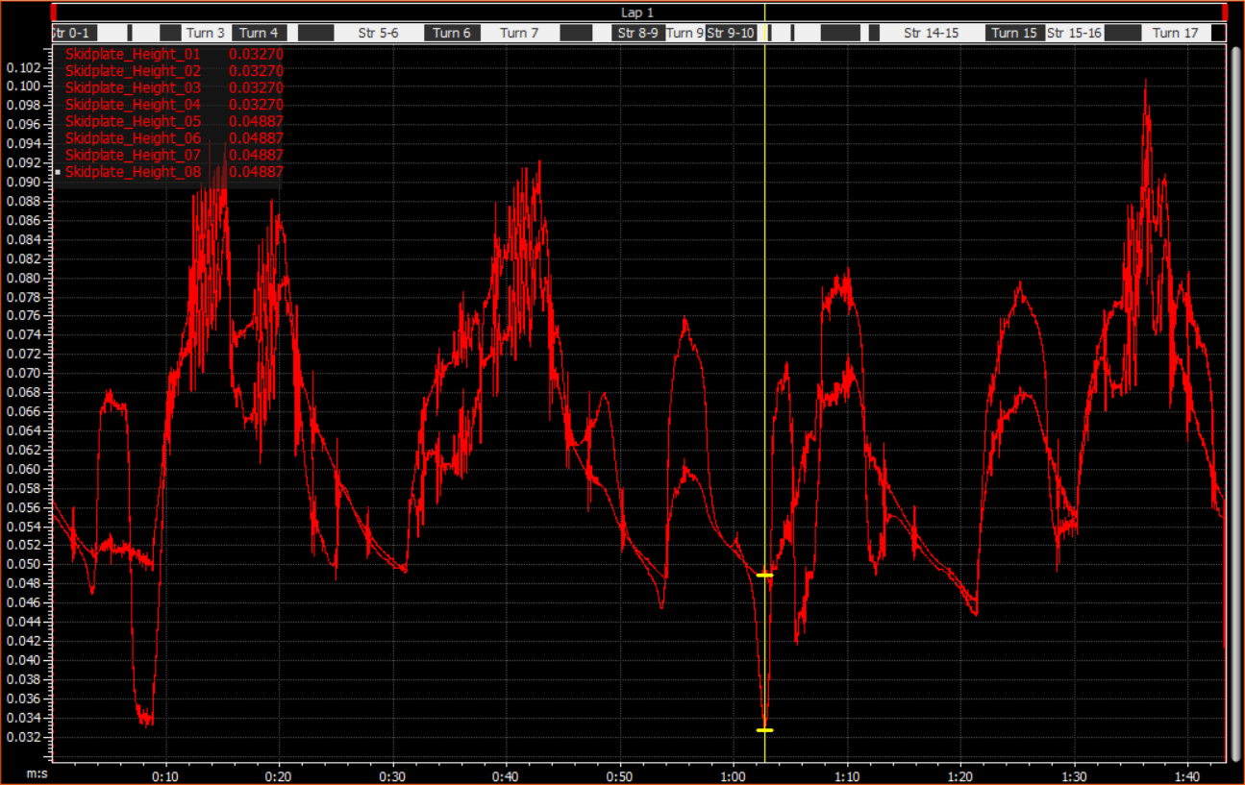

There was no place on the track where the car was bottoming out. We get closest to the track in T10.

1. **Having opened the gap to 5mm, how would you assess the general performance of the run? Is there any improvement in aerodynamics? Is there any improvement in ride?**

**Ans:**

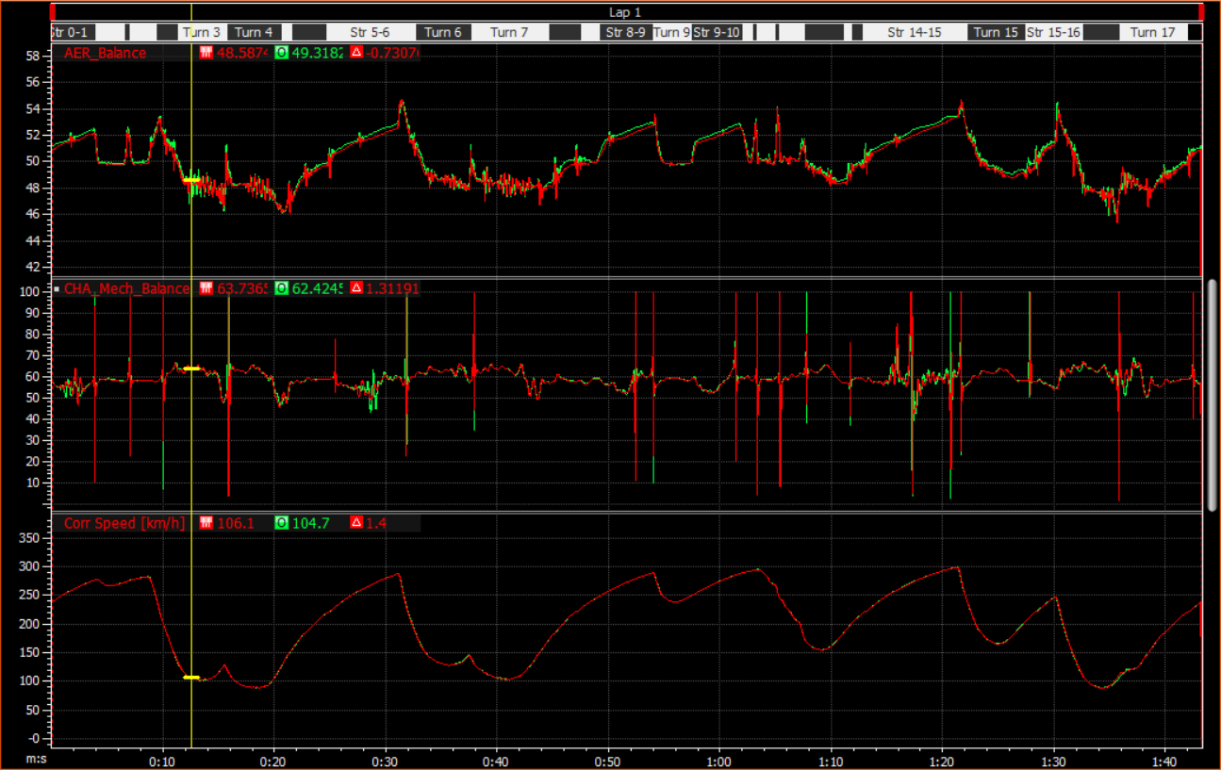

Yes, there is a general performance change by opening the gap in damper it shifted the aero and mechanical balance slightly forwards. This change increased the front downforce therefore high speed cornering performance. The mechanical balance moved forwards which moves weight distribution forwards increasing understeer in slow speed corners. As indicated in the above overlay the entry speed into T3 is around 2 km/h slower.

**Blind Evaluation Test**

1. The objective is to identify what the change is and explain/justify why you have come up with this solution. In addition, evaluate if this change has any potential, where the time loss is, and why.

Ans: 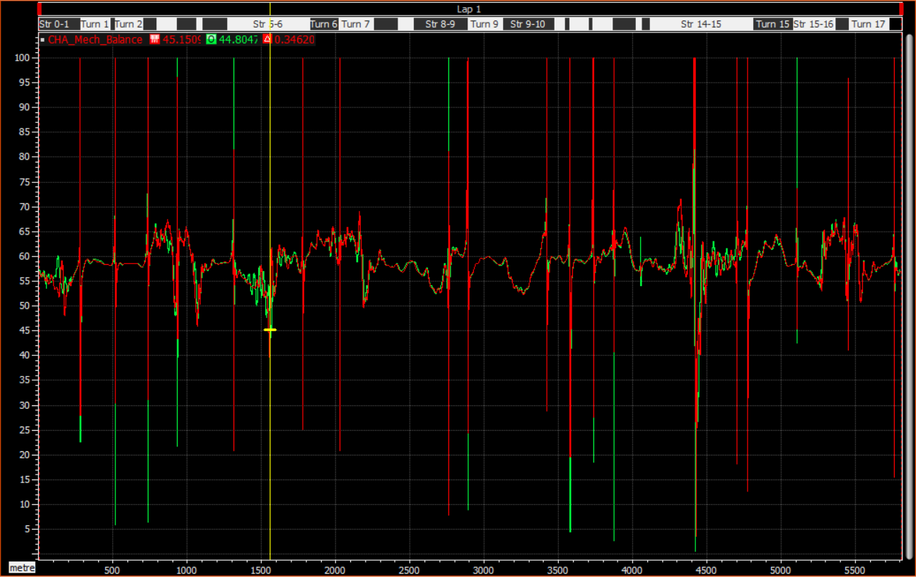

As we can see from mechanical balance overlay it has shifted slightly forwards compared to baseline setup. This might happen because of softer springs, softer dampers or change in ride height.

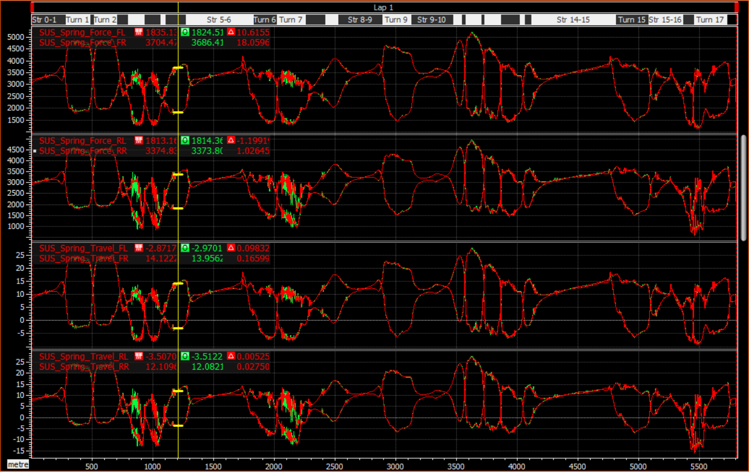

We can see from the above suspension spring force and travel overlay there is fluctuation in slow right corners of T3 and T7 indicating softer springs on the car.

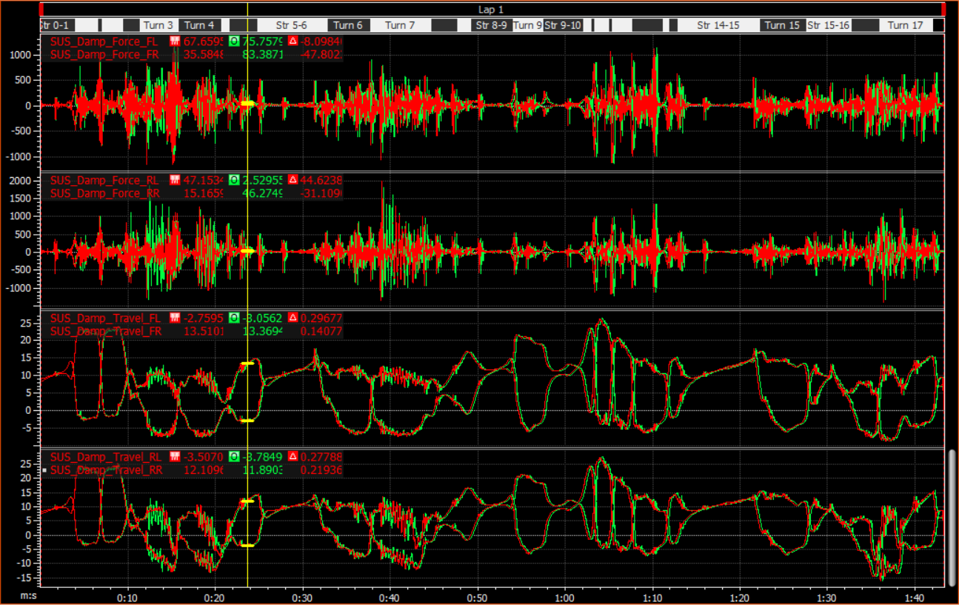

Above is the overlay of damper force and travel. This overlay also shows fluctuations at the same corners as suspension overlay.

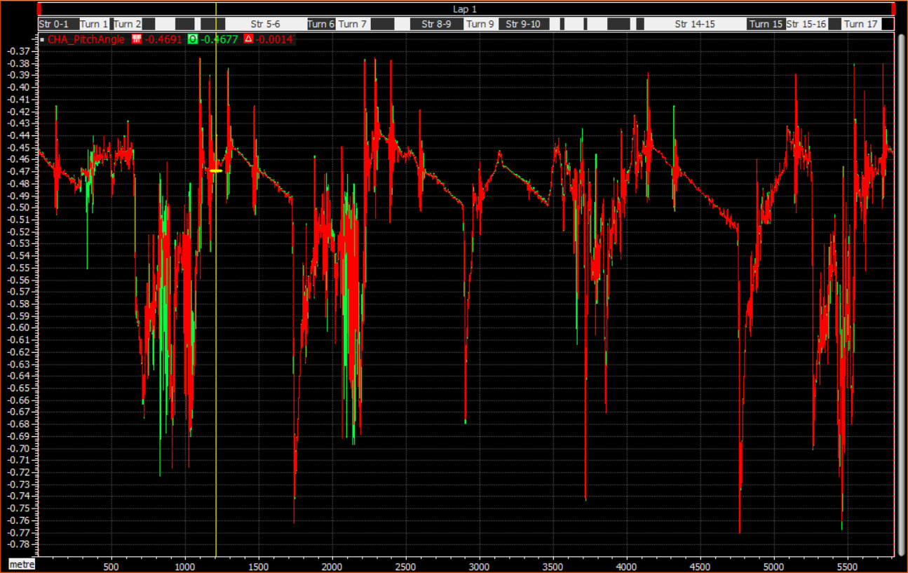

We can see from above pitch angle overlay that there is excessive oscillations in T3. By all the above evidences we can say that they have softened the dampers which can be confirmed from the oscillations from the above graphs. Soft dampers cause excessive oscillations and increase the time for the suspension to comeback into steady state because they don’t dissipate spring energy as effectively as the stiffer dampers and they also cause more dive under braking which we can see in pitch angle overlay.

1. **Analyse the mechanical change on this setup and, using the data, approximate how much the heave and roll stiffness has changed compared to the baseline.**

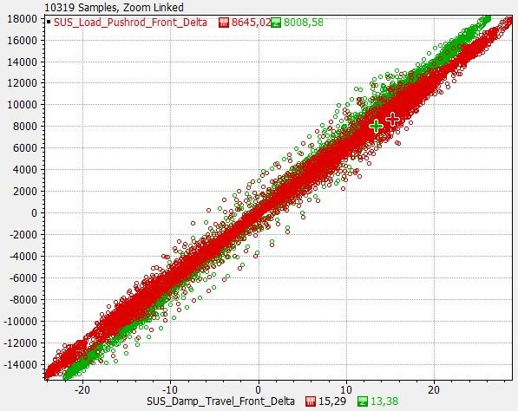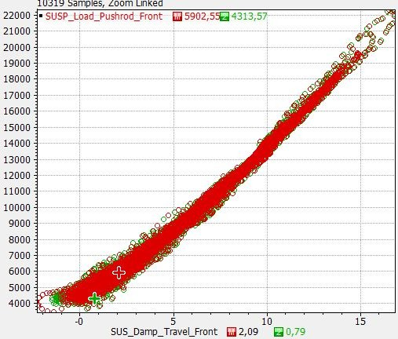

**Ans:** As the front damper travel increased the pushrod load increased. From the pushrod load front vs damper travel delta plot as the damper travel delta increases there is more pushrod load delta than the baseline setup this is because there is an increase in stiffness of spring. There is approximately 5% increase in heave stiffness and 10% increase in roll stiffness compared to the baseline.

1. **What do you suggest could have happened between one run and the other?**

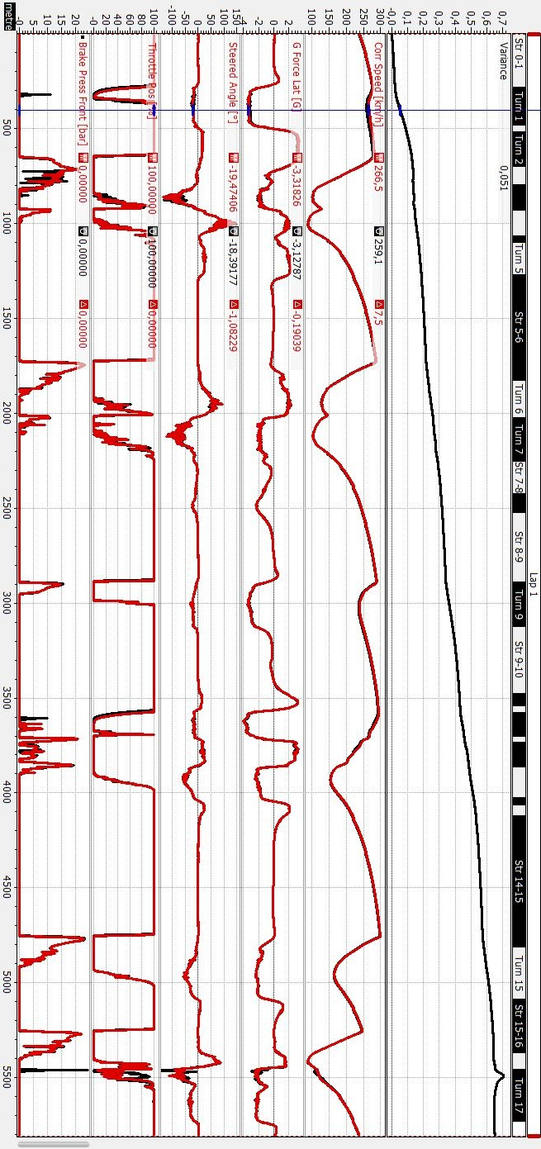

**Ans:** As indicated in the graph in the mid corner of T1 the speed is 7.5km/h less than the baseline setup which is because of the increase in roll stiffness. There is also more time loss out of the high speed corners such as T1 & T2, T9 and T13 onto hangar straight. The driver was not able to carry the same amount mid corner speed as he/she did with baseline setup.